

**60% of all reported injuries in Chevron this year**

**are slips, trips and falls**

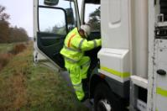 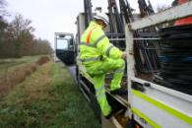

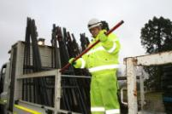 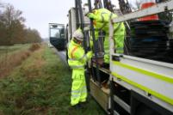

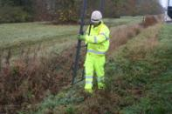

**\* Vehicle cabs (in and out)**

**Always 3 points of contact**

**\* Flat bed of trucks**

**Guard rails must be in place at all times, except when the vehicle is**

**stationary, and then only when equipment is being loaded or off loaded**

**\* Verge & centre reserve (long grass)**

**Look out for kerbs; beware in long grass of discarded TM frames,**

**pot holes, uncovered excavations, manholes or inspection chambers**

**\* Safety boots**

**Are laces tied properly; are boots fit for purpose?**

Watch your Step!



25 Nov 2011